| Discussion: Is Hilo the next Pompeii?

Overview
Lab 11 focuses on volcanoes. There are many hazards associated with these landforms. In this discussion, we look at the threats Hilo, Hawaii faces compared to Pompeii, Italy.

Instructions
For this discussion, you will use your knowledge of the different types of volanoes to compare and contrast the circumstances the two cities face.
- Use Google Earth to look up both cities (Hilo, HI and Pompeii, Italy). Review the information and explore the surrounding areas.
- Use the information and your knowledge of volcano types to answer the following questions.

Initial Post
Please answer the following in your initial post:
- Name the volcanoes each city is located near.
- What type of volcano is near Hilo? What about Pompeii?
- Based on your volcano type knowledge, is Hilo going to have the same fate as Pompeii? Explain your reasoning.
.
Please remember to use the rules of Netiquette when making your posts and replies. 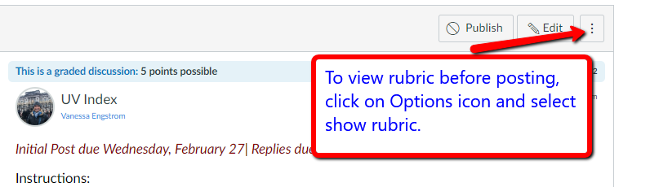

Lab 12 | Discussion: Are you prepared for an Earthquake?

Overview
Lab 12 focuses on faults and earthquakes. Living in Southern California, earthquakes are a large part of our lives. They happen often and for the majority of time, they are not felt. However, when larger ones occur, it is always good to be prepared. The purpose of this discussion is to become aware of the hazards associated with earthquakes and how to prepare for them in advance.

Instructions
For this discussion, you will learn about earthquake hazards by reading the Earthquake preparedness document and watching the hazard videos included here. After doing this, make your post.
Read: how-to-prepare-for-an-earthquake.pdf
Actions
Watch:
Great Shake Out videos (7 in total) (Links to an external site.)

Initial Post
Please answer the following in your initial post:
- Have you ever thought about preparing for an earthquake?
- Have you done anything to prepare for an earthquake before now? If so, what?
- Using the How to Prepare for an Earthquake PDF, what are some steps you can take to better prepare yourself/your household? (Example: Do you have any of the things on the Personal Item list (pg. 6)? If so, what do you have? If not, what do you plan on getting? House safety?)
- Optional question: Do you have any earthquake experiences you would like to share?

Lab 14 | Discussion: Desertification

Overview
In this week's material, we learn about desertification. Desertification is an environmental problem many countries and people are dealing with around the world. With this discussion, I want you to learn about this issue and solutions / strategies being used to combat it.

Instructions
For this discussion, you will be responding to a National Geographic article (Links to an external site.) on desertification and the short videos I've provided below. After reading the section, watch the videos and make your initial post.

https://youtu.be/w9RxnuBiFbg
https://youtu.be/4xls7K_xFBQ
https://youtu.be/qz9SbkAMDNg
https://youtu.be/MfCHXWi2Gzk

Initial Post
Please answer the following in your initial post:
- In your own words, explain desertification.
- List two strategies / solutions to combat this issue.
- If where you live was being threatened by desertification, what strategies / solutions would you implement? Please explain.

